ROK Mobile Phone Emergency Message Translation

Emergency Alerts are sent to Korean mobile phones. Follow the steps below to receive emergency messages in English:

1. Download “EmergencyReadyApp” (spelled as one word) through the Google Play Store or iOS App Store
2. Open the app and select “Setting”, in the bottom right-hand corner (Figure 1)  
   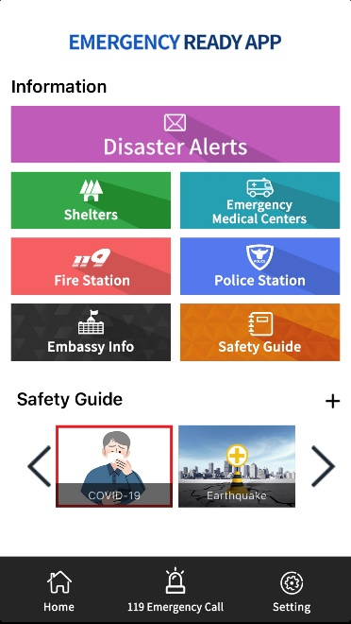

Figure 1

1. To Set Up Emergency Alerts for Kunsan:
   1. Select “Set Receive Area” (Figure 2)  
          
      Figure 2
   2. Turn “Set preferred location” to ‘ON’ (Figure 3)

  
Figure 3

* 1. Select the blue button “Add area” below the white box
  2. Scroll down area list, select “Jeollabuk-do” provincial (Figure 4)

Figure 4

* 1. Then, Select ““Jeollabuk-do_Gunsan-si” (Figure 5)  
        
     Figure 5

1. To Set Up Emergency Alerts for Other Districts
   1. For Osan:
      1. Follow steps 3a-c, then select “Gyeonggido” provincial, “Osan-si”
   2. For Camp Humphreys:
      1. Follow steps 3a-c, then select “Gyeonggido” provincial, “Pyeongtaek-si”
   3. For Busan:
      1. Follow steps 3a-c, then select “Busan” provincial, “Busan”
   4. For Seoul:
      1. Follow steps 3a-c, then select “Seoul” provincial, “Seoul”